# **DISASTER RECOVERY**

1. **AWS Region Selection:** Choose a geographically distant AWS region from the primary region where your current resources are hosted. This ensures geographic separation for better resilience.
2. **EC2 Instances:** Backup and AMIs: Implement automated daily backups for your EC2 instances using Amazon EBS snapshots. Create Amazon Machine Images (AMIs) regularly for critical instances to facilitate quick recovery. Cross-Region Replication: Set up cross-region replication for your critical EC2 instances. This can be achieved using AWS services like AWS Backup or custom scripts with AWS CLI. Load Balancers: Leverage Elastic Load Balancers (ELB) in both the primary and DR regions for distributing traffic and ensuring high availability.
3. **RDS Instances:** Automated Backups: Enable automated daily backups for your RDS instances. Using snapshot method.

* A snapshot will be taken every 1 hour from Mumbai region and will be shared to Hyderabad Region. This method would require at least an hour of RTO (Recovery Time Objective). And data loss will eventually occur as the RDS would require some time to get into functional state.
* We can reduce the RTO by using Cross Region Read Replica of the RDS(Multi-AZ). But we can implement Cross Region Read Replica on RDS that uses MySQL Enterprise Edition and has following versions:
* RDS for SQL Server 2019 (Version 15.00.4073.23 and higher).
* RDS for SQL Server 2017 (Version 14.00.3049.1 and higher).
* RDS for SQL Server 2016 (Version 13.00.5216.0 and higher).
* In both the cases the recovery time is changing. Data loss will occur in both the cases

1. **Network Configuration:** Direct Connect or VPN: Establish a Direct Connect or VPN connection between the primary and DR regions to ensure secure and fast communication.
2. **Route 53:** Utilize Amazon Route 53 for DNS failover, directing traffic to the DR site in case of a disaster.

**Mumbai Region Failure:**

* All the server that has applications hosted on them will be present in Mumbai Region as well as in Hyderabad Region.
* A multi-AZ RDS will be present in Mumbai Region and a Read Replica for that RDS will be available into Hyderabad Region.
* In the backend, testing will be done at application level where it is checked whether the application is receiving data from Mumbai Region’s RDS endpoint (Primary), and if not then a secondary RDS endpoint is provided i.e. of read replica RDS present in Hyderabad region.
* After that we will be using a Lambda function that will promote the read replica RDS to primary RDS in Hyderabad Region.
* Now the application would be receiving the data from Hyderabad Region’s RDS.
* Also, with the help of failover routing policy, the request of application will be routed to Hyderabad Region RDS.

**Rollback to Mumbai Region:**

* If the Mumbai region gets active again, we can rollback all the traffic to Mumbai Region from Hyderabad Region
* Now the application is getting request from RDS of Hyderabad Region although Mumbai Region is active.
* So, a read replica of Hyderabad’s RDS will be created in Mumbai Region and it will be promoted to primary RDS.
* After that read replica RDS will be again created in Hyderabad Region from the promoted RDS present in Mumbai Region
* Then the application team will change the endpoint in the application and will be using the endpoint of newly promoted RDS present in Mumbai Region.
* After that we will take down the promoted RDS present in Hyderabad region

**Diagram:**

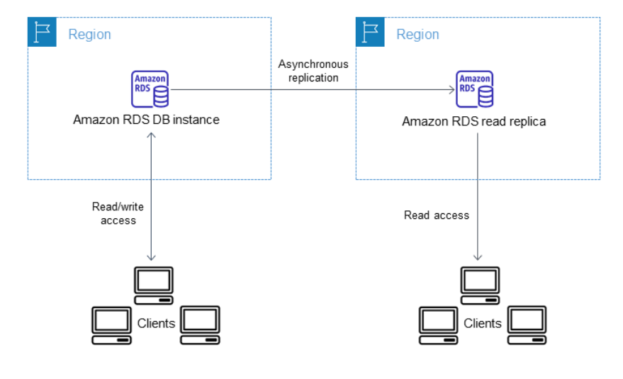

**Architecture:**

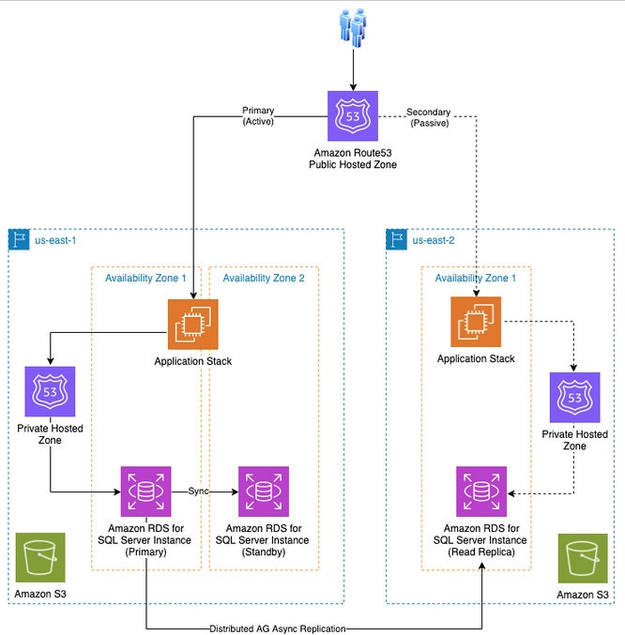

**Conclusion:**

By leveraging AWS disaster recovery and backup solutions, improvements in data protection, business continuity, and operational efficiency. Disaster events pose a threat to your workload availability, but by using AWS Cloud services you can mitigate or remove these threats. By first understanding business requirements for your workload, you can choose an appropriate DR strategy. Then, using AWS services, you can design an architecture that achieves the recovery time and recovery point objectives your business needs. This documentation demonstrates the effectiveness of AWS solutions in providing comprehensive disaster recovery and backup for businesses of all sizes and across diverse industries.